Brazil visa procedures

Go to <https://scedv.serpro.gov.br/frscedv/indexIdiomaIngles.jsp?lang=eng> to get started (may work best with google chrome

-Select “visa request” button

-Complete requested information

-Select the “submit” button

-You should be given a visa application number

Go back to <https://scedv.serpro.gov.br/frscedv/indexIdiomaIngles.jsp?lang=eng>

-Select “update visa request form” button

-You will be required to enter the application number and applicants date of birth

-Hit the “search” button

-Select the “send file” button

-Choose the type of document for upload. You will need to upload the following:

1) Photo/jpeg format,

2) Business letter/pdf format (which ITS Travel Office will provide)

3) Applicant’s signature/jpeg format

-Once you get all three documents uploaded (see screenshot below), you will need to select the “update” button

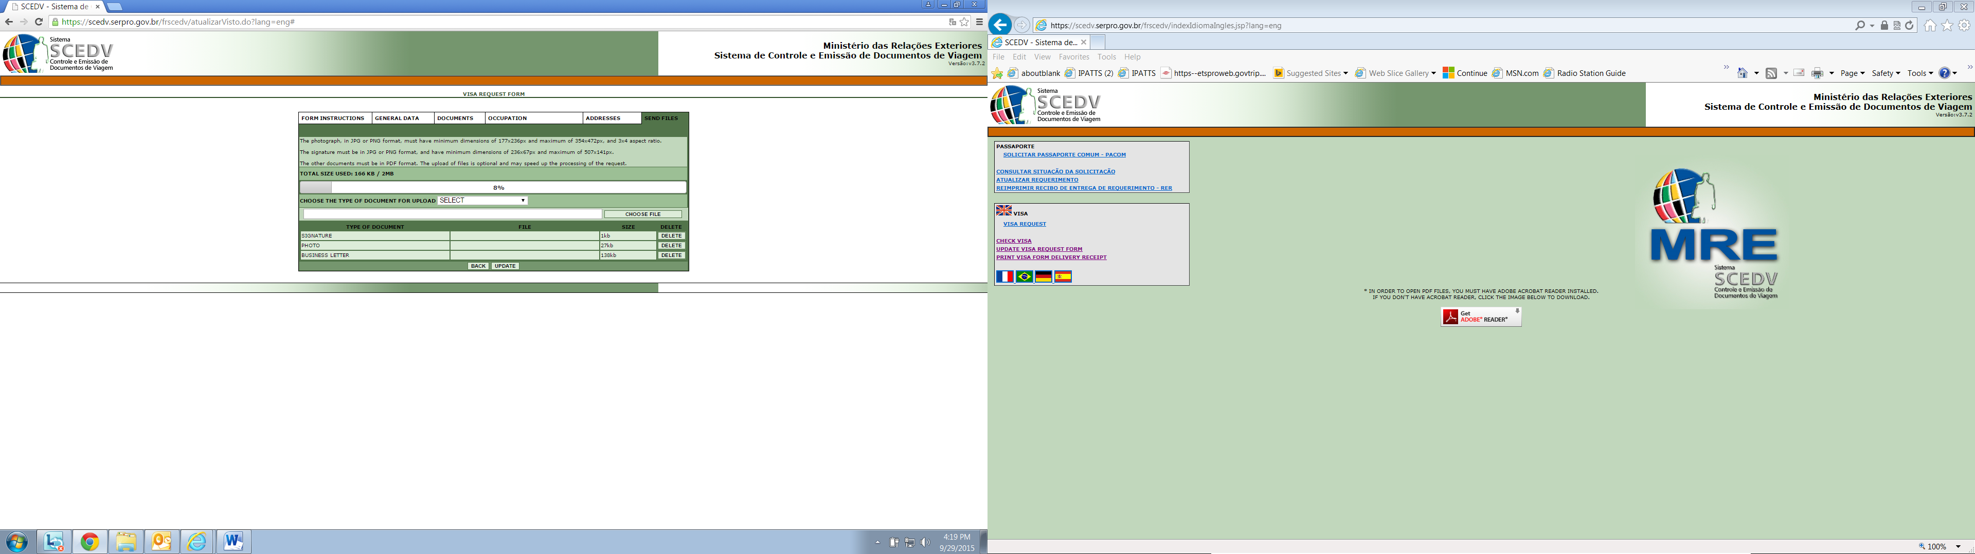

Go back to <https://scedv.serpro.gov.br/frscedv/indexIdiomaIngles.jsp?lang=eng>

* Select “Print Visa Form Delivery Receipt” button
* You will be required to enter the application number and applicants date of birth
* Select the “search” button
* The visa cover page will generate
* Save this document as a PDF file, you will need to add the photo to it (see procedures below
* Print Cover Page with Photo on it and submit to FAS Travel Office, room 1069-S

-

1. Resizing the photo
   1. Open picture (jpeg format)
   2. Open picture with paint
   3. Select the resize button
   4. Select the pixels button
   5. Put 177 in the horizontal box
   6. Put 236 in the vertical box
   7. Deselect the “maintain aspect ratio” box
   8. Select ok
   9. Save picture as jpeg file
2. Adding picture to Brazil Cover Page
   1. Save Cover page as a pdf document
   2. Select tools button
   3. Select Add Image Button
   4. Select the picture you saved
   5. Picture will drop onto page
   6. Drag and drop the picture into the photo box on the cover page, must fit within the box