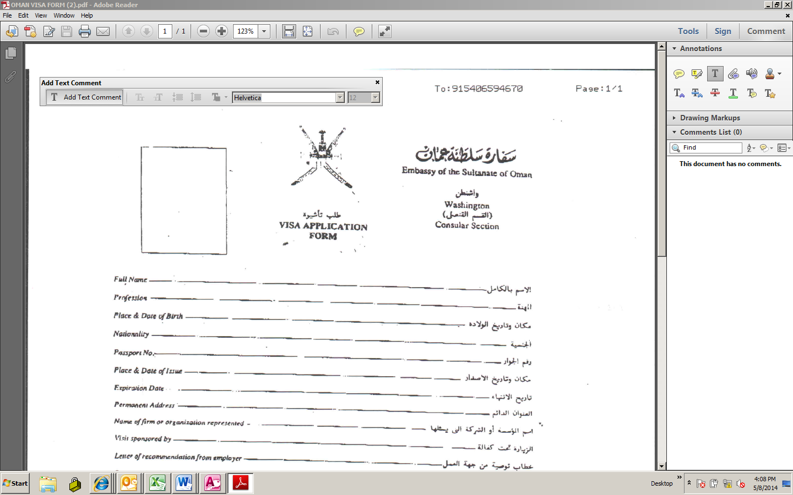

← Begin typing # 3

↑

This will allow you to edit the type of text ( Size , Color , Font )

#2 Please Press the T →

# 1 Please press the Comment button ↓

↑ ↓ → ←